EUCHNER at AMB 2026:

CRA-ready! With EUCHNER.
Under the guiding principle of connected, safe, and efficient manufacturing, EUCHNER will showcase its latest innovations for industrial automation at AMB 2026 in Stuttgart (Hall 8, Booth C59). Trade fair highlights include the EKS2, the latest generation of the Electronic-Key-System, the MGB2 Modular safety door system, pioneering IO-Link Safety solutions, and comprehensive concepts addressing cybersecurity and the requirements of the Cyber Resilience Act (CRA).
Protect what we create. CRA-ready! With EUCHNER.
Cybersecurity is increasingly becoming a critical success factor in machine and plant engineering. It complements functional safety and plays a key role in ensuring the availability, integrity, and confidentiality of modern production systems. With the Cyber Resilience Act (CRA), the European Union is establishing a uniform legal framework for the cybersecurity of products with digital elements. “We took the right steps early on: Since the beginning of the year, our development process has been certified according to IEC 62443-4-1, making EUCHNER CRA-ready. At the same time, we have established a Product Security Incident Response Team (PSIRT) and entered into a cooperation with the VDE’s Cyber Emergency Response Team (CERT@VDE). This reinforces our commitment to delivering permanently secure and robust products in accordance with the Cyber Resilience Act,” explains Bernd Hermann, Head of Development at EUCHNER. At the same time, the company supports machine manufacturers and operators with comprehensive consulting on cybersecurity requirements in the industry. This includes threat and risk analyses, the identification of security vulnerabilities, and assistance with the implementation of “security-by-design” concepts. EUCHNER is here to support as a trusted partner for any questions regarding compliance, vulnerability management, and security updates.
End-to-end safe communication with IO-Link Safety
By combining robust safety components with IO-Link Safety, EUCHNER is opening up new possibilities for end-to-end, safe communication in automation.
The last 20 meters between the control system and field devices have long been considered the bottleneck of automation: Sensors and actuators had to be wired individually, while increasing requirements for safety and diagnostics continuously raised the complexity of cabling. With IO-Link Safety, EUCHNER offers a solution that significantly reduces this complexity. Instead of many individual wires, a single standardized connection is sufficient for transmitting data and signals.
This enables end-to-end, safe communication from the control system to the sensor and back. Switches, guard locking, and door systems can be efficiently integrated and flexibly incorporated into modern machine designs. The safe transmission of actuator IDs up to SIL3 / PL e also opens up new fields of application, such as the safe position monitoring of moving machine parts.
Comprehensive diagnostic functions enable detailed real-time status and error analysis, simplify device replacement, and reduce maintenance efforts. This increases system availability and enhances efficiency throughout the entire machine lifecycle.
Digital access control for smart factories
With the EKS2 Electronic-Key-System, EUCHNER simplifies the safe selection of operating modes and the management of access rights in modern production environments.
In combination with the new EKM2 Electronic-Key-Manager and an integrated database, keys can be managed centrally on a PC. Variable role and authorization concepts can thus be easily implemented and flexibly adapted to different shift and organizational structures.
Predefined templates, data encryption, a hygienic IP69K design, and direct PROFINET connectivity ensure rapid integration into existing automation solutions.
Scalable safety door system for flexible production concepts
Machines and production lines are constantly evolving. The MGB2 Modular grows with these requirements. The fully modular safety door system can be flexibly adapted to new machine concepts, line expansions, or retrofit projects. For maximum communication flexibility, the bus module supports the common Industrial Ethernet protocols PROFINET, EtherCAT(P), and EtherNet/IP.
An integrated Ethernet switch further reduces wiring effort and simplifies the network topology. At the same time, the system combines access control, operation, and signaling in a single solution. With an IP65 protection rating, temperatures down to -30 °C, and safety levels up to PL e / SIL3, the MGB2 Modular is particularly well-suited for demanding applications in machine and plant engineering.
Visit EUCHNER at AMB 2026 in Hall 8, Booth C59, and learn how modern safety technology, digital access concepts, and cybersecurity solutions are shaping the future of production.

For editorial use:
Meta Title: EUCHNER at AMB 2026: Protect what we create
Meta Description: At AMB, EUCHNER is focusing on comprehensive solutions related to cybersecurity and the requirements of the Cyber Resilience Act (CRA).

Social Media Post: At AMB 2026 in Stuttgart (Hall 8, Booth C59), EUCHNER will present innovative solutions for safe and efficient automation. Highlights include the EKS2 Electronic-Key-System, the MGB2 Modular safety door system, modern IO-Link Safety solutions, and concepts related to cybersecurity and the Cyber Resilience Act (CRA). Visitors will learn how safety, connectivity, and efficiency can be optimally combined in modern machine designs.

Images: Euchner GmbH + Co. KG
01-EUCHNER – IO-Link Safety
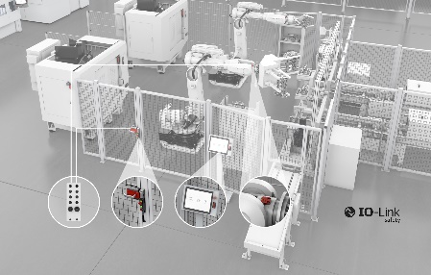
By combining robust safety components with IO-Link Safety, EUCHNER is opening up new possibilities for seamless, safe communication in automation.

02-EUCHNER – Electronic-Key-System EKS2
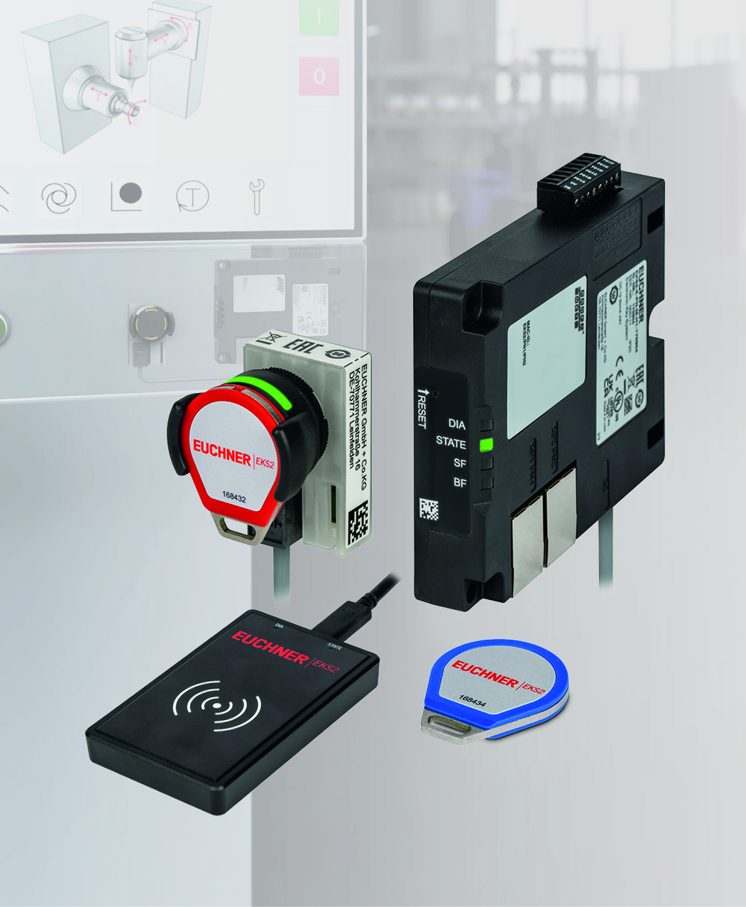
With the EKS2, EUCHNER simplifies the selection of safe operating modes.

03-EUCHNER – MGB2 Modular
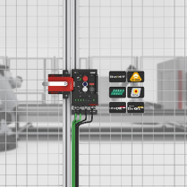
The modular design of the MGB2 with standard components enables customized and cost-effective applications with high flexibility in implementation and scaling. The bus module, which supports PROFINET, EtherCAT(P), and EtherNet/IP, ensures versatility in communication.

High-resolution images are available for download here.

About EUCHNER GmbH + Co. KG
EUCHNER GmbH + Co. KG, headquartered in Leinfelden, is an internationally active family-owned company and ranks among the world’s leading experts in industrial safety technology. With more than 900 employees, 21 subsidiaries, and a global network of distribution partners, EUCHNER is represented in all major markets.
The company is led by managing partner Stefan Euchner, who combines the tradition of the family business with a clear focus on the future.
Under the motto “More than safety,” EUCHNER has been developing and manufacturing customized solutions for safety technology for over 70 years. Its broad portfolio of more than 7,000 products ensures that people, machines, and processes are reliably protected worldwide and across all industries—from automation technology to machine tools.
EUCHNER Safety Services complement the portfolio and support manufacturers and operators throughout the entire lifecycle of machines and systems with professional consulting, training, and engineering services.
For more information about the company, visit www.euchner.com

EUCHNER GmbH + Co. KG
Kohlhammerstraße 16
70771 Leinfelden-Echterdingen
Germany
Tel. +49 711 7597-0
www.euchner.com
info@euchner.de

Press Contact
Stefanie Möllenkamp-Bolduan
Head of Marketing Communications
Phone: +49 711 7597-275
st.moellenkamp@euchner.de





Social Media

