EUCHNER presents IO-Link Safety solutions at the Hannover Messe
Focus on the last 20 meters
“Think Tech Forward” is the motto of this year’s Hannover Messe (April 20–24). In keeping with this motto, EUCHNER will present its latest developments in Hall 27, Booth F50. Highlights from the safety technology expert include the EKS2, the latest generation of the Electronic-Key-System, the MGB2 Modular safety door system, and the IO-Link Safety solutions, which significantly simplify wiring over the last 20 meters.
Leinfelden, March 19, 2026 – The last 20 meters in automation have long been a bottleneck: Sensors and actuators had to be wired individually – the more safety signals and diagnostic data that needed to be transmitted, the more complex the wiring became. EUCHNER solves this problem with the use of IO-Link Safety. Instead of many wires, only a single cable is needed for the last 20 meters to transmit data and signals. By combining robust safety components with IO-Link Safety, EUCHNER enables end-to-end, safe communication in automation – all the way from the control system to the sensor and back. Switches, guard locking, and door systems can be efficiently connected via a standardized interface. This significantly reduces planning and installation effort. The safe transmission of actuator IDs (up to SIL3 / PL e) enables entirely new applications, such as the safe position monitoring of moving machine parts.
In addition, comprehensive diagnostic functions reduce maintenance requirements and thereby increase system availability. This is complemented by hassle-free device replacement and detailed real-time status and error diagnostics.
Scalable safety door system
Machine and plant concepts are changing – the MGB2 Modular grows with them. The fully modular safety door system adapts flexibly to changing requirements. Thanks to seamless integration into PROFINET, EtherCAT(P), and EtherNet/IP, the system can be configured for all common control architectures. An integrated Ethernet switch reduces wiring effort and simplifies the network topology. MGB2 Modular offers access control, operation, and signaling in a single device. It is extremely robust (down to -30 °C, IP65) and meets the highest safety level (PL e / SIL3). This makes it suitable for modular production lines, line conversions, or retrofit projects, among other applications.

Digital access control for smart factories
Also on display in Hanover: EUCHNER’s EKS2 Electronic-Key-System, which offers centralized, tamper-proof access management for connected production environments with variable roles and shift models. In combination with the new EKM2 Electronic-Key-Manager and the integrated database, keys can be flexibly managed on a PC. Predefined templates, data encryption, a hygienic IP69K design, and direct PROFINET connectivity make integrating the EKS2 into existing automation solutions particularly efficient.
Cybersecurity takes center stage
Connected devices fall within the scope of the Cyber Resilience Act (CRA) and will be subject to corresponding cybersecurity requirements starting at the end of 2027. EUCHNER offers a wide range of digital products. “We took the right steps early on: Since the beginning of the year, our development process has been certified according to IEC 62443-4-1, making EUCHNER CRA-ready. At the same time, we have established a Product Security Incident Response Team (PSIRT) and entered into a cooperation with the VDE’s Cyber Emergency Response Team (CERT@VDE). This reinforces our commitment to delivering permanently secure and robust products in accordance with the Cyber Resilience Act,” explains Bernd Hermann, Head of Development at EUCHNER. The standard certifies that manufacturers of automation components have a Secure Development Lifecycle (SDL) for industrial control systems (IACS).
EUCHNER at the Hannover Messe: Hall 27, Booth F50

For editorial use:
Meta Title: EUCHNER presents IO-Link Safety solutions at the Hannover Messe
Meta-Description: At the Hannover Messe, EUCHNER is focusing on its IO-Link safety solutions, which significantly simplify wiring over the last 20 meters.
Social media post: At this year’s Hannover Messe (April 20–24), EUCHNER will present its latest developments in Hall 27, Booth F50: Among other things, the current generation of the EKS2 Electronic Key System and the MGB2 Modular safety door system. The focus at the booth is on IO-Link safety solutions. EUCHNER solves the bottleneck of the last 20 meters in automation with a single cable that transmits everything. Users benefit from a uniform, standardized interface, reduced planning and installation effort, and detailed real-time status and fault diagnostics.

Images: Euchner GmbH + Co. KG
01-EUCHNER – IO-Link Safety
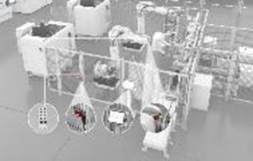
By combining robust safety components with IO-Link Safety, EUCHNER opens up new possibilities for seamless, safe communication in automation.

02-EUCHNER – MGB2 Modular
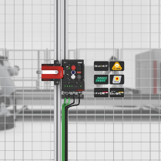
The modular design of the MGB2 with standard components enables customized and cost-effective applications with high flexibility in implementation and scaling. The bus module, which supports PROFINET, EtherCAT(P), and EtherNet/IP, ensures versatility in communication.

03-EUCHNER – Electronic Key System EKS2
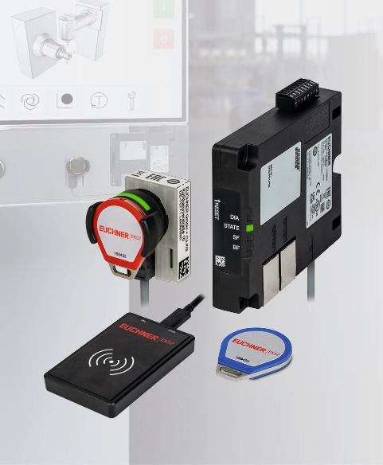
With the EKS2, EUCHNER simplifies the selection of safe operating modes.

High-resolution images are available for download here.

About EUCHNER GmbH + Co. KG
EUCHNER GmbH + Co. KG, headquartered in Leinfelden, is an internationally active family-owned company and ranks among the world’s leading experts in industrial safety technology. With more than 900 employees, 21 subsidiaries, and a global network of distribution partners, EUCHNER is represented in all major markets.
The company is led by managing partner Stefan Euchner, who combines the tradition of the family business with a clear focus on the future.
Under the motto “More than safety,” EUCHNER has been developing and manufacturing customized solutions for safety technology for over 70 years. The broad portfolio of more than 7,000 products ensures that people, machines, and processes are reliably protected worldwide and across all industries—from automation technology to machine tools.
EUCHNER Safety Services complement the portfolio and support manufacturers and operators throughout the entire lifecycle of machines and systems with professional consulting, training, and engineering services.
For more information about the company, visit www.euchner.com

EUCHNER GmbH + Co. KG
16 Kohlhammerstraße
70771 Leinfelden-Echterdingen
Germany
Tel. +49 711 7597-0
www.euchner.com
info@euchner.de

Press Contact
Stefanie Möllenkamp-Bolduan
Head of Marketing Communications
Phone: +49 711 7597-275
st.moellenkamp@euchner.de





Social Media

