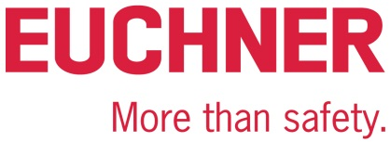

PRESS RELEASE
Leinfelden, November 06, 2025

EUCHNER at SPS 2025
Safe automation despite increasing requirements
At SPS in Nuremberg (November 25 to 27), EUCHNER will be exhibiting innovative safety products for automated production at Booth 280 in Hall 7. The company’s solutions meet the latest communication requirements in networked processes. They can be seamlessly integrated to provide the best possible protection for people, machines, and plants.
Increasing demands for more flexibility, productivity, and availability are accompanied by ever more complex safety engineering, putting manufacturers of plants and machines under huge pressure. EUCHNER ensures safe end-to-end communication from the control system through to the sensors with its robust components and IO-Link Safety. This standardized, non-proprietary interface allows switches and guard locking and door systems to be connected efficiently, resulting in a significant reduction in planning and installation work. Comprehensive diagnostic functions also simplify troubleshooting, reduce maintenance costs, and increase plant availability.
Networking without limits
At its booth, EUCHNER will also be exhibiting its safety door system MGB2 Modular, which has the flexibility to adapt to changing requirements. It can be seamlessly integrated into PROFINET, EtherCAT (P), and EtherNet/IP networks and is designed to be compatible with all current control system architectures. An integrated Ethernet switch reduces the amount of wiring needed and simplifies the network topology. In addition to access control, the MGB2 Modular also allows for machine operation and signaling. It is robust (temperatures as low as -30 °C, IP65) and complies with safety level PL e/SIL3.
The Electronic-Key-System EKS2 from EUCHNER is a central access management solution that is secure against tampering and is designed for networked production environments with variable roles and shift schedules. If access is not actively managed, the system prevents incorrect operation, downtimes, and safety gaps. In combination with the Electronic-Key-Manager EKM2 and the integrated database, the Electronic-Keys can be managed flexibly from a PC. Predefined templates, data encryption, hygienic IP69 design, and the direct PROFINET connection simplify the integration of the system into existing automation solutions.
Flexible and versatile
Visitors to the EUCHNER booth will also have the opportunity of finding out more about the CTS compact safety switch. This has an impressive locking force of up to 5,000 newtons and can be installed in a variety of ways in hinged and sliding doors. Its actuator, which is mounted on a floating bearing, can withstand vibration and offset mounting. The FlexFunction allows for a variety of applications with only one device. In the past, these applications would have required several switch variants. The safety switch is accompanied by a comprehensive range of accessories, including an extendable escape release, a lockout mechanism, and mounting plates, which enable the flexible installation of the CTS and the actuator. An installation kit with a handle simplifies the integration of the safety switch into access doors. There is also a variant with a mounting magnet that keeps accesses closed even in the event of heavy vibration and prevents unwanted noise. With different connections available, the safety switch can be directly connected to decentralized fieldbus modules and other control systems.
Become a safety expert
The EUCHNER Safety Services add the finishing touch to the company’s presence at the trade fair. Visitors can test their knowledge of safety engineering by taking a safety quiz at the EUCHNER booth and by identifying safety defects on the 3D model of a machine.
The company also demonstrates how, with its Safety Services, it supports its customers throughout the world on all issues relating to machinery safety and the new EU Machinery Regulation. There is also the opportunity of training to become a TÜV-certified expert in production and machinery safety. For more information and registration options, visit: www.euchner.de/en-us/about-euchner/dates

Euchner at the SPS trade fair: Hall 7, Booth 280

Service for the editorial team:
Meta title: EUCHNER at SPS 2025 – Innovative safety solutions for networked machines
Meta description: EUCHNER at SPS 2025 in Nuremberg (Hall 7, Booth 280): MGB2 Modular, EKS2 Electronic-Key-System, and CTS safety switch – flexible, robust, and easily integrated.
Social media post: At SPS 2025 in Nuremberg (November 25–27, Hall 7, Booth 280), EUCHNER will be presenting innovative safety solutions for networked machines: the flexible safety door system MGB2 Modular, the central Electronic-Key-System EKS2, and the compact CTS safety switch. Visitors can test their knowledge by taking a safety quiz and identifying safety defects on a 3D machine.

Pictures: Euchner GmbH + Co. KG

01-EUCHNER – Safety switches with IO-Link Safety
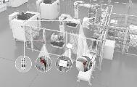
EUCHNER has combined its proven, robust safety components with the benefits of safe communication via IO-Link Safety.

02-EUCHNER – MGB2 Modular
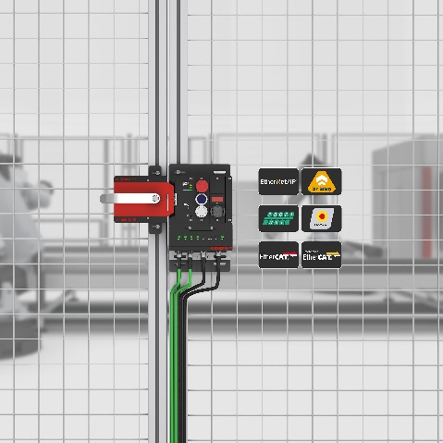
The MGB2 Modular can be customized to suit all requirements and is now also available for EtherNet/IP / CIP Safety.

03-EUCHNER – Electronic-Key-System EKS2

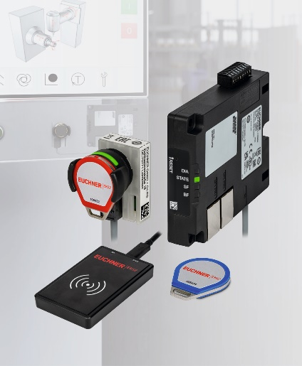
With the EKS2, the latest generation of the Electronic-Key-System from EUCHNER, users can easily manage and customize access to machines and their functions and ensure that they are secure against tampering.
04- EUCHNER – CTS safety switch
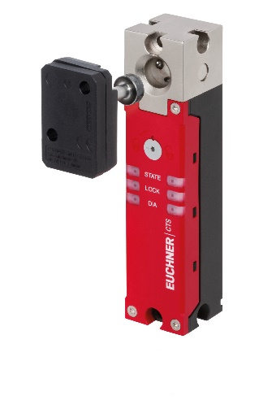
The compact CTS safety switch has an impressive locking force of up to 5,000 newtons and can be installed in a variety of ways in hinged and sliding doors.

About EUCHNER GmbH + Co. KG
EUCHNER GmbH + Co. KG, headquartered in Leinfelden, is a globally active, family-owned company and one of the world’s leading industrial safety engineering experts. With over 900 employees, 21 subsidiaries and a global distributor network, EUCHNER is present on all important markets.
The company is run by Managing Partner Stefan Euchner, who combines the tradition of the family-owned company with a clear, forward-looking approach.
In keeping with its maxim, “More than safety,” EUCHNER has been developing and producing tailor-made safety engineering solutions for over 70 years. Its wide range of over 7,000 products reliably protects people, machines and processes around the world and in all sectors – from automation engineering to metal-cutting machinery.
EUCHNER Safety Services complement the portfolio and support manufacturers and operators alike with professional consulting, training and engineering services over all machine and installation life-cycle phases.
More information about the company is available on the Internet at www.euchner.com

EUCHNER GmbH + Co. KG
Kohlhammerstraße 16
70771 Leinfelden-Echterdingen
Germany
Tel. +49 711 7597- 0
Fax +49 711 753316
www.euchner.com
info@euchner.de

Press contact
Stefanie Möllenkamp-Bolduan
Head of Marketing Communications
Tel. +49 711 7597- 275
st.moellenkamp@euchner.de





Social media

